CODE FOR ROCK, PAPER & SCISSORS

**21CSS101J – PROGRAMMING FOR PROBLEM SOLVING**

**Mini Project Report**

*Submitted by*

***SANKALP SAHU [*Reg. No.: RA2211003011373]**

**B.Tech. CSE -Core**

***GARVESH SINGH RATHORE* [Reg. No.: RA2211003011364]**

**B.Tech. CSE – Core**



**SCHOOL OF COMPUTING**

**COLLEGE OF ENGINEERING AND TECHNOLOGY**

**SRM INSTITUTE OF SCIENCE AND TECHNOLOGY**

**(Under Section 3 of UGC Act, 1956)**

S.R.M. NAGAR, KATTANKULATHUR – 603 203

KANCHEEPURAM DISTRICT

**December 2022**

Table of the Content

|  |  |  |
| --- | --- | --- |
| Chapter  No. | TITLE | Page no. |
| 1. | Program statement | 4 |
| 2. | Description | 5 |
| 3. | Methodology/ procedure | 6 |
| 4. | Code | 7-8 |
| 5. | Result | 9 |
| 6. | Code Compiler screenshots | 10-13 |
| 7. | Conclusion | 14 |

**Problem Statement:**

# Write a **program to implement Rock Paper Scissor game.**

Description :-

It is a simple command-line Rock-Paper-Scissor game without using any external game libraries like PyGame. In this game, the user gets the first chance to pick the option between Rock, paper, and scissors. After the computer select from the remaining two choices (randomly), the winner is decided as per the rules.

* Methodology & Procedure:-

By using if & else statement In python the user gets the first chance to pick the option between Rock, paper, and scissors. After the computer select from the remaining two choices(randomly), the winner is decided as per the rules.

* **Winning Rules as follows:**

Rock vs paper-> paper wins

Rock vs scissor-> Rock wins

paper vs scissor-> scissor wins.

Code –

// Online C compiler to run a python program online.

import random

print("Winning Rules of the Rock paper scissor game as follows: \n"

+ "Rock vs paper->paper wins \n"

+ "Rock vs scissor->Rock wins \n"

+ "paper vs scissor->scissor wins \n")

while True:

print("Enter choice \n 1 for Rock, \n 2 for paper, and \n 3 for scissor \n")

choice = int(input("User turn: "))

while choice > 3 or choice < 1:

choice = int(input("enter valid input: "))

if choice == 1:

choice_name = 'Rock'

elif choice == 2:

choice_name = 'paper'

else:

choice_name = 'scissor'

print("user choice is: " + choice_name)

print("\nNow its computer turn.......")

comp_choice = random.randint(1, 3)

while comp_choice == choice:

comp_choice = random.randint(1, 3)

if comp_choice == 1:

comp_choice_name = 'Rock'

elif comp_choice == 2:

comp_choice_name = 'paper'

else:

comp_choice_name = 'scissor'

print("Computer choice is: " + comp_choice_name)

print(choice_name + " V/s " + comp_choice_name)

if choice == comp_choice:

print("Draw=> ", end="")

result = Draw

if((choice == 1 and comp_choice == 2) or

(choice == 2 and comp_choice == 1)):

print("paper wins => ", end="")

result = "paper"

elif((choice == 1 and comp_choice == 3) or

(choice == 3 and comp_choice == 1)):

print("Rock wins =>", end="")

result = "Rock"

else:

print("scissor wins =>", end="")

result = "scissor"

if result == Draw:

print("<== Its a tie ==>")

if result == choice_name:

print("<== User wins ==>")

else:

print("<== Computer wins ==>")

print("Do you want to play again? (Y/N)")

ans = input().lower

if ans == 'n':

break

print("\nThanks for playing")

**RESULT**

**Output:**

winning Rules of the Rock paper and scissor game as follows:

rock vs paper->paper wins

rock vs scissors->rock wins

paper vs scissors->scissors wins

Enter choice

1. Rock

2. paper

3. scissor

User turn: 1

User choice is: Rock

Now its computer turn.......

computer choice is: paper

Rock V/s paper

paper wins =>computer wins

do you want to play again?

N

SCREENSHOT OF CODES->

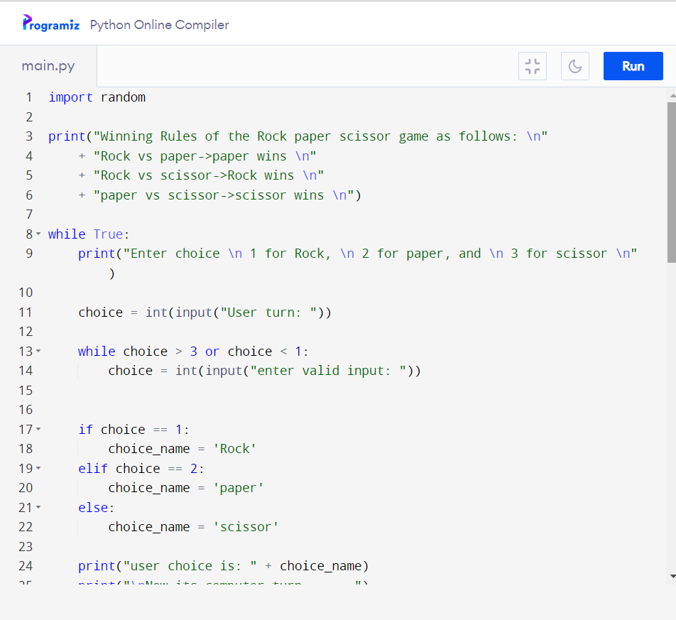

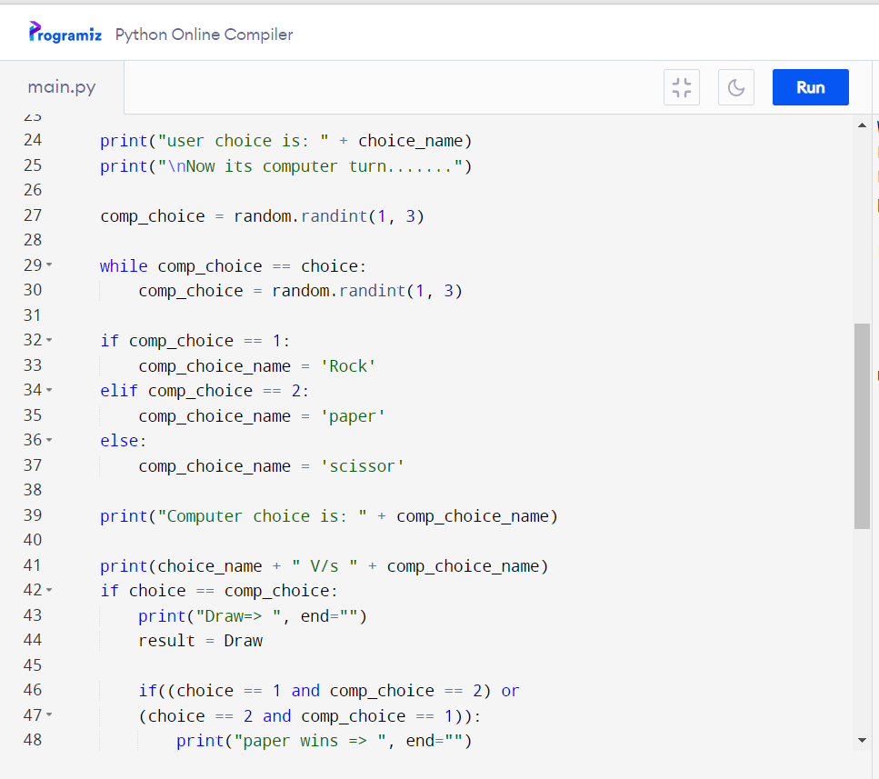

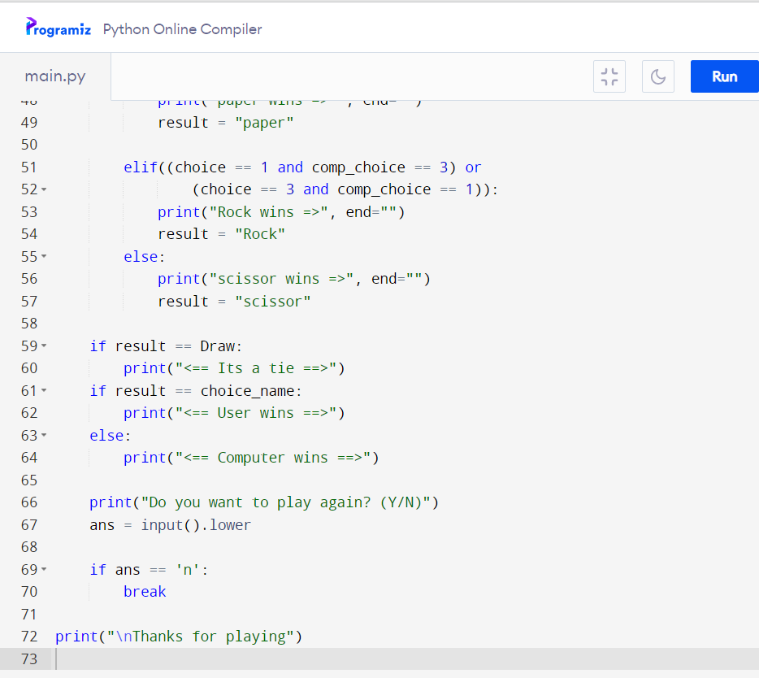

OUTPUT->

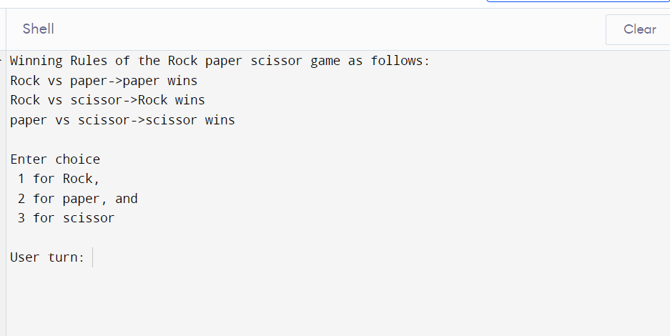

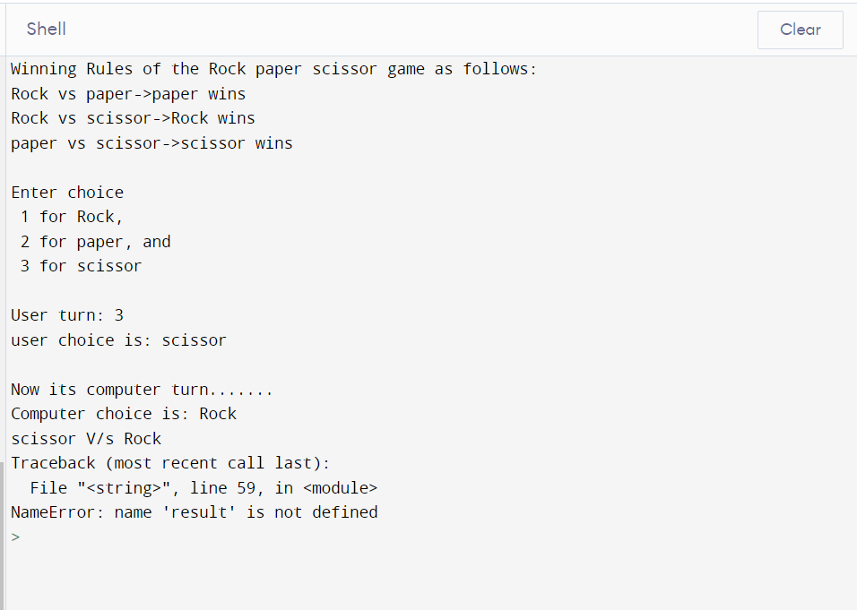

Conclusion:-

So here’s the program for the game of rock , paper and scissor in python. This game requires one player who plays against the computer.